

Individual assignment cover sheet

Course Name: | Master of Information Systems (Cyber Security)
Unit Number and Name: | MIS5303 Securing Software
Lecturer Name: | Dr Omid Haass
Assignment No.: | Assessment 1 - Practical Labs (Lab 2)

Declaration:
By submitting this declaration, I, the below-named student, declare the following:

- Except where appropriately acknowledged, this assignment is my own work and has been expressed in my own words.
- Where I have made use of generative AI software, I have done so appropriately and cited it accurately as per the ‘HE-AP19 Generative Artificial Intelligence (AI) Guidelines for Students’ document found in the LMS, See: HE-AP19 Generative Artiificial Intelligence (AI) Guidelines for Students.pdf (apexhe.nsw.edu.au).
- This assignment in its entirety, or this particular part of it, has not previously been submitted by me or any other person for assessment on this or any other course of study.
- I have read the Student Academic Misconduct Policy and Procedure found at https://apexhe.nsw.edu.au/policiesandprocedures/, and I understand the significance of academic integrity and the consequences of breaching it.

Use of Generative Artificial Intelligence (AI)

Please tick one of the following options:
- Declaration 1: I acknowledge using AI tool(s) to generate content that are included in this work in modified forms.
- Declaration 2: I acknowledge the use of AI tool(s) in the preparation of material that aids the process of completion of this assignment (e.g. for self-study or background reading). No materials are submitted as original work on our part.
- Declaration 3: I did not use any content generated by AI tools in the preparation of this assignment

If your response was Declaration 1 or Declaration 2, please complete the following:

 | Student’s Response
AI Tool(s) Used (e.g., ChatGPT, Grammarly, DALL·E 2, Pi Assistant, Lumen5, Looka, etc.) | ChatGPT
Purpose of Use (Explain specifically what the tool was used for – e.g., idea generation, grammar correction, image generation, summarizing content, etc.) | - Understanding the problems.  - Grasping the notion.  - Fixing strategy learning.
List all prompts you have used
Extent of Modification (Explain if and how you rewrote or modified the AI-generated content. E.g., rephrased, fact-checked, rearranged, quoted suitably, etc. | - Checked the fixing.  - Explanation of the fixing.
Consider the manners in which your work is different from AI-generated contents.
How have you modified the generative AI's output?

Note: All AI usage must be acknowledged and comply with the HE-AP19 Generative Artificial Intelligence (AI) Guidelines for Students. Unacknowledged use of AI tools constitutes academic misconduct.

Student ID Number: | Student Name:
240135 | Ashraful Islam

Signed: Date: 25-Jul-26

1. Findings — Input Flaws
ID | Vulnerability | Where (file / route) | OWASP / ref | Severity | Why it is risky
F1 | Stored XSS | notes list template (|safe) | A03:2021 Injection | High | Saved script runs in any viewer's browser; can steal session cookies
F2 | SQL injection | index() notes query | A03:2021 Injection | High | Crafted username returns all users' notes; could read/alter other data
F3 | No input validation | add_note() | A03 / input handling | Medium | Empty or oversized notes accepted with no checks

Evidence — before remediation
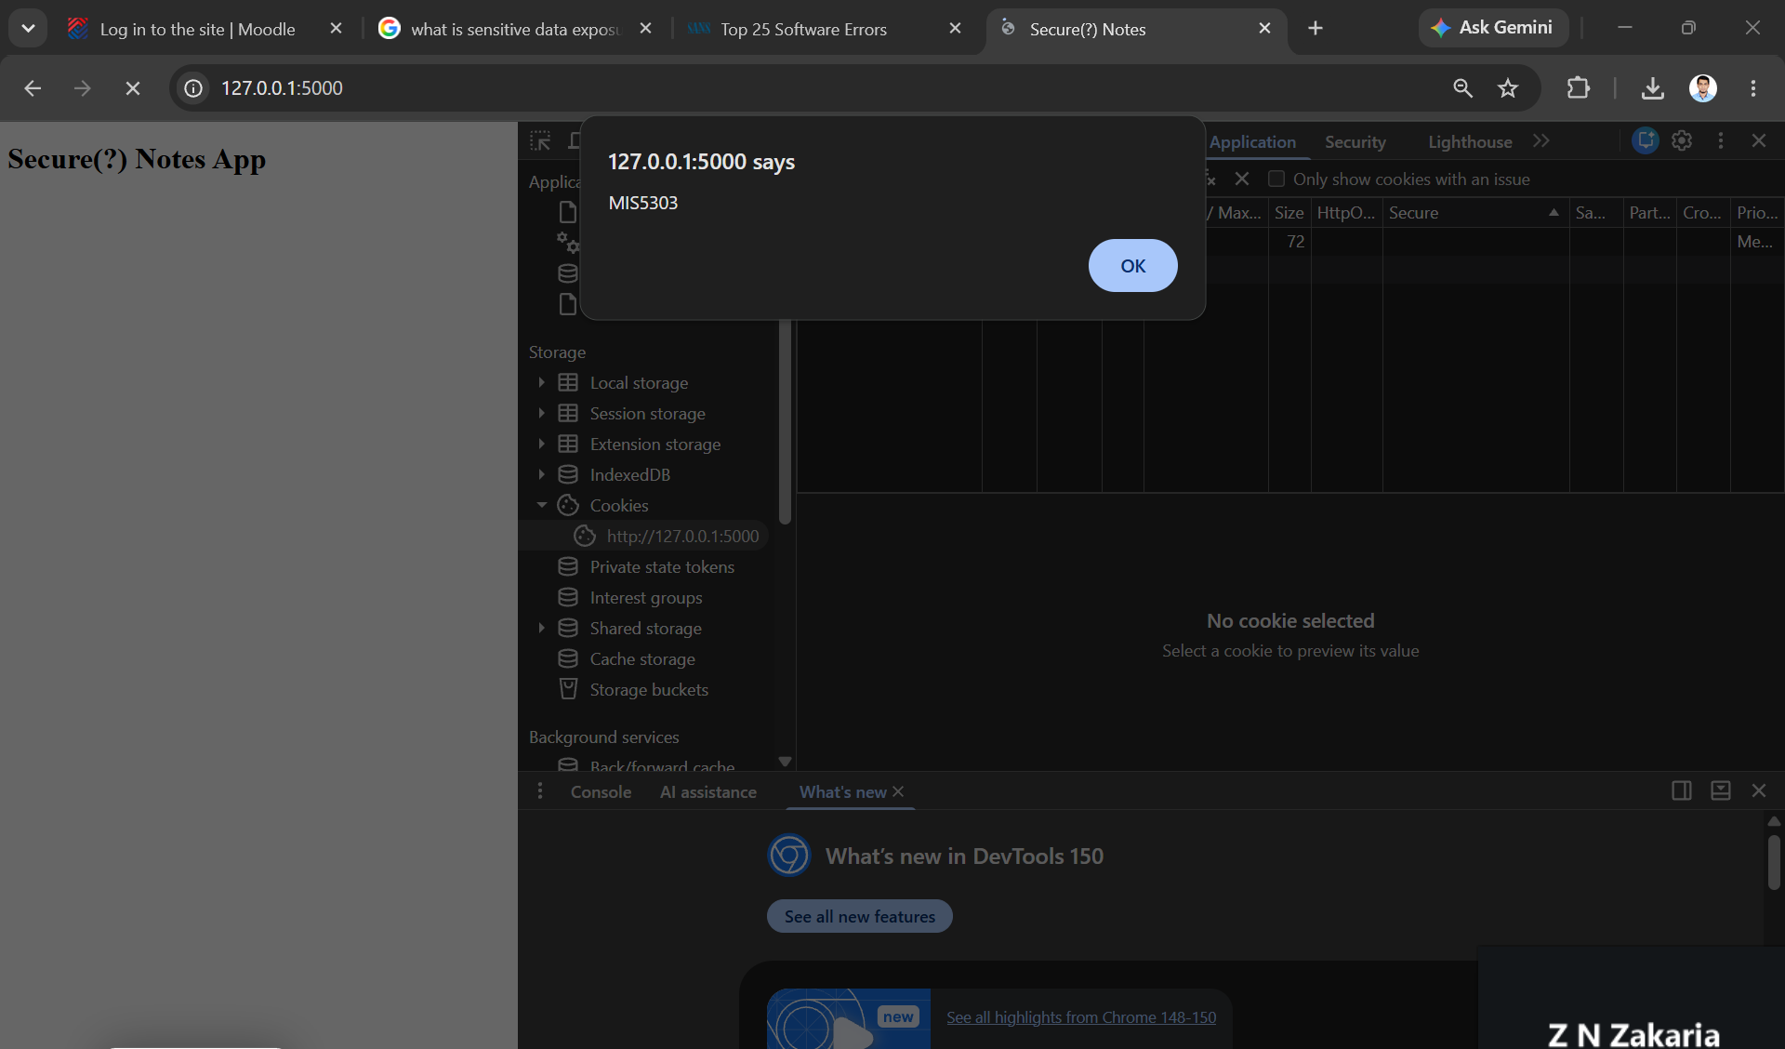
Figure 1: Stored XSS — a note containing <script>alert('MIS5303')</script> executes and triggers a pop-up.
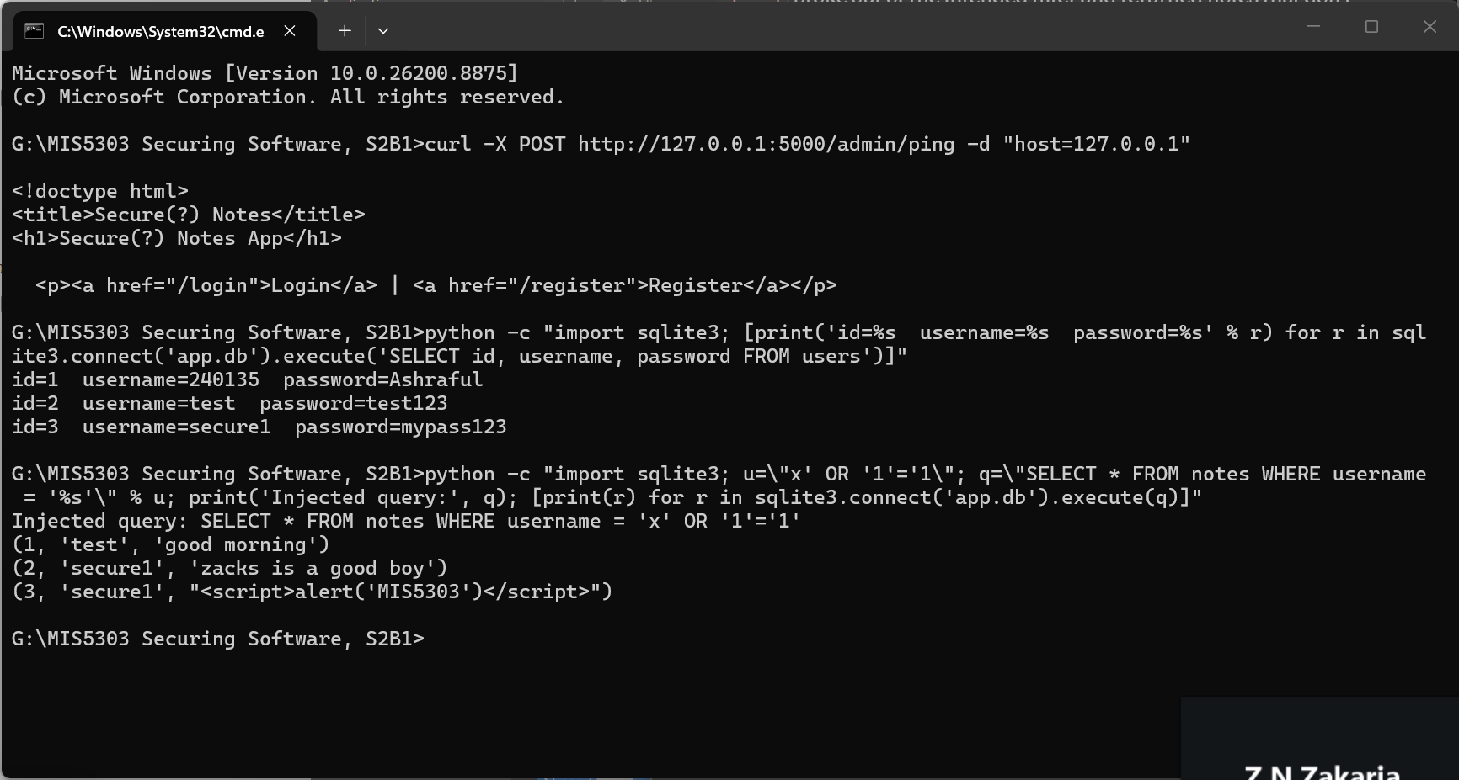
Figure 2: SQL injection — username x' OR '1'='1 makes the query return every user's notes (test and secure1).

2. Remediation — Secure Code (Before / After)

2.1 SQL injection → parameterised query
Before — vulnerable (f-string builds the SQL):
query = f"SELECT * FROM notes WHERE username = '{session['username']}'"
notes = conn.execute(query).fetchall()
After — secure (bound parameter):
notes = conn.execute(
"SELECT * FROM notes WHERE username = ?",
(session['username'],)).fetchall()

2.2 Stored XSS → output escaping
Before — vulnerable (|safe disables escaping):
{% for n in notes %}<li>{{ n['content']|safe }}</li>{% endfor %}
After — secure (auto-escaping restored):
{% for n in notes %}<li>{{ n['content'] }}</li>{% endfor %}

2.3 Input validation
if not content or not content.strip():
return redirect(url_for('index', error='Note cannot be empty.'))
if len(content) > 500:
return redirect(url_for('index', error='Note is too long...'))

Evidence — after remediation (re-test)
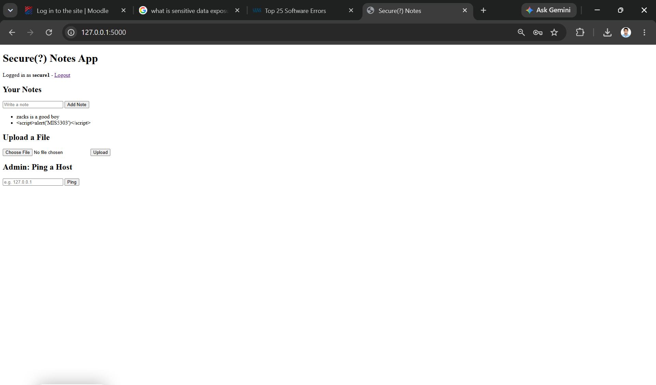
Figure 3: After the fix — the stored script now displays as plain text with no pop-up.
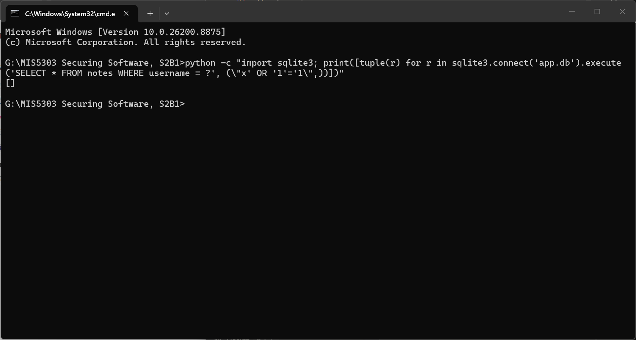
Figure 4: After the fix — the parameterised query treats the payload as a literal username and returns no rows ([]).
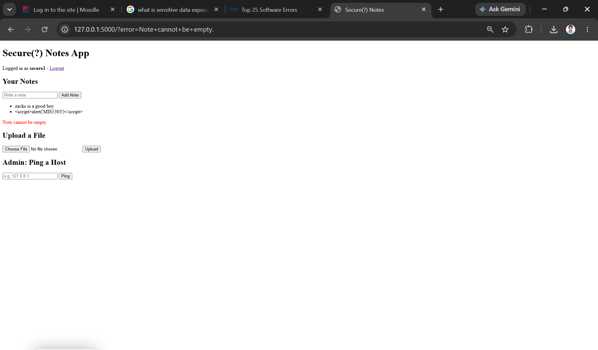
Figure 5: Input validation — submitting an empty note is rejected with a red "Note cannot be empty" message.

3. Secure Data Flow Diagram & Rationale
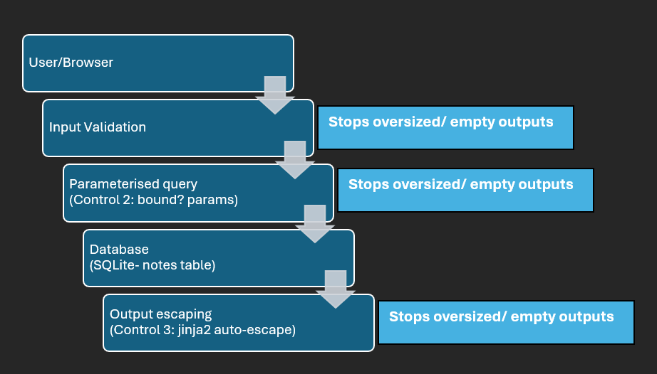
Figure 6: Secure data-flow diagram showing the three control points.

Control points
Control | Where it sits | What it stops
1. Input validation | add_note() — on entry | Empty / oversized input
2. Parameterised query | index() — database boundary | SQL injection
3. Output escaping | notes template — on output | XSS on display

Then write 1–2 paragraphs (own words): why these control points, and how they prevent BOTH SQLi and XSS.
[ Your answer here ]

4. Individual Reflection
I typed <script>alert('MIS5303')</script> into a note. Instead of showing it as text, the app ran it like a program and a pop-up appeared. This is dangerous because an attacker could use the same method to inject a script that steals another user's session cookie and can hijack their account. To fix it, I removed the word |safe from app.py, which had been telling the app to trust and run the content. After the fix, the app escapes the input, so the same <script> now displays as plain text with no pop-up.
When I clicked "Add Note" with the box empty, the app saved an empty note. There was no check on what users typed. To fix this, I added validation in app.py that rejects empty or overly long notes and shows an error message instead of saving them. After the fix, submitting an empty note gave a red font alert showing a "Note cannot be empty" message.
One thing I comprehend is that my fixes did not work at first and the pop-up kept showing even after I amended the code. This was because the app was still running the old version in the browser and in memory. Only after I stopped and restarted the app did the fix take effect. This taught me that a fix isn't proven until you restart and re-test it.
The app had a tricky flaw that shows everyone's notes whoever is logging in. I logged in as x' OR '1'='1 and broke the command so eventually it returned everyone's notes that were posted by "test" and "secure1" users. To amend this issue, I changed the code and used a "?" placeholder. Now the username is treated as plain data, not as part of the command, so that trick returns nothing.

